UI Design - Learning Outcome 2

Responsive design for different screen sizes:
The UI design is made in a way that makes it better suited to screen sizes for that of something like a laptop or a desktop, as with a phone or smaller the UI will become a bit squashed, a tablet could also probably work but it would require a rework of the controls to work on a touchscreen. But for the most part t intended size is for laptop/PC, I think the game would look a bit weird on a touchscreen or smaller device, as the tile set may be a bit jarring.

UI/UX decisions:
My UI is made in a way that is very simplistic having very few details and instead opting to go towards function over form, it displays what the UI is (IE, health) and then how much the player has (IE 100 when you start, 0 when you die etc), but for stuff like the menus and similar, I’ve placed the UI in the middle, below the title of the game(s) (of which there is none) and continued on the trend of being simplistic, my Godot game as only 2 buttons on the main menu, 1 to play, and another to view the controls of the game. Speaking of, the controls are laid out in a similar way to the title screen, the title of the page up the top in the middle, and the middle of the screen showcasing the controls

Wireframes/Mock-ups:
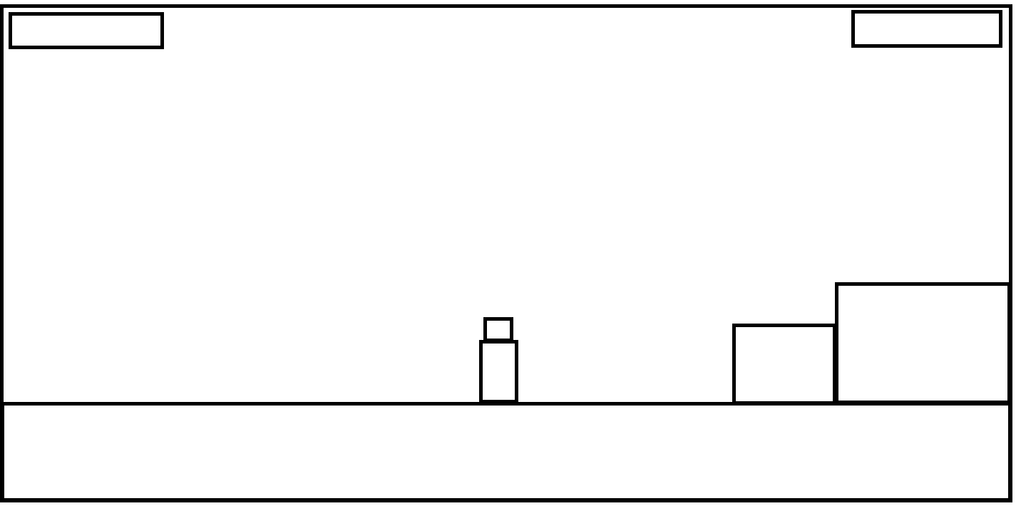
The UI for my GODOT game during actual gameplay is very simplistic, having the health and score in the top left and right respectively.

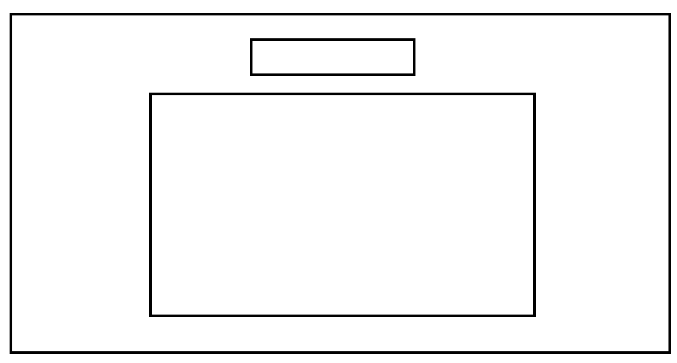
The UI for my controls page in my Godot game

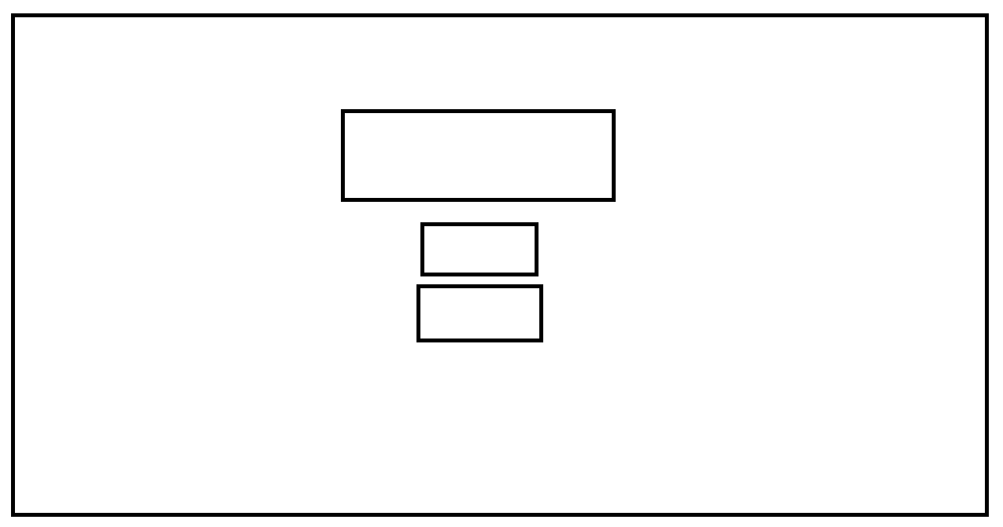
The main menu UI, again very simplistic with the big title with smaller buttons below it, akin to something like Minecraft.

